Lesson Plan Format Guidelines:

Paper Size: A4 (8.3 x 11.7 in / 21.0 x 29.7 cm); or
Letter (8.5 x 11.0 in / 21.6 x 27.9 cm) (US’ standard)
Margin: Top – 1 in / 2.54 cm Bottom – 0.5 in / 1.27 cm
Left – 0.5 in / 1.27 cm Right – 0.5 in / 1.27 cm

Front Size: Mark Pro & Mark Pro Medium
Title (e.g. Lesson 4 Visualizing the Global Warming) – 18 points Mark Pro Medium, Bold Added
Heading (e.g. Objectives/Activities/Section 1 Introduction/…) – 14 points Mark Pro Medium, Bold Added
Sub-heading (e.g. Procedure/Step 1/…; headings within the main content) – 11 points Mark Pro Medium, Bold Added
Main content – 11 points Mark Pro
Bold added for emphasis when necessary
Indentation: not for the main content
Line Spacing: 1.5 lines (or 22 points at least)

Spelling and punctuation:
American English and rules for North America
British English and rules for the Commonwealth, and the EU

Use endnotes rather than footnotes
Works cited: Harvard reference, cf. https://www.imperial.ac.uk/admin-services/library/learning-support/reference-management/harvard-style/

Delivery: PDF


Lesson 7:
A network game

Subject: STEAM Grade(s): 5th and up
Duration: 45 minutes Difficulty: Beginner

 Lesson objectives
By the end of this lesson, students will be able to:
- Have multiple mBot2 communicate with each other wirelessly without the need for a WIFI access point
- Write their own computer program in mBlock to control multiple mBot2
- Apply a random selection in a computer program

Overview
LAN is the abbreviation for Local Area Network. The mBot2, with its built-in WIFI module, automatically establishes a network connection as soon as there are multiple mBot2 or CyberPi in the same room within a 30-meter radius. Over this network connection, the mBot2 and CyberPi can communicate with each other and execute commands.

 Focus
By the end of this lesson, students will know:
- What a LAN connection is
- How to set up this connection and where to apply it
- How random selection works when programming

 Pre-lesson Checklist
What do you need?
- PC or laptop (with USB output) with the mBlock software installed, the web version (also for Chromebook), or a tablet with the mBlock app installed
- The mBot2 with a CyberPi (multiple mBot2 and/or CyberPi if possible, for the Trying Out step)
- A USB-C cable or Makeblock Bluetooth dongle
- Color cards (blue is suggested)

 Lesson plan
This lesson consists of four steps and takes a total of 45 minutes.
Duration | Contents
5 minutes | 1. Warming up  - A LAN connection in everyday life  - How to set up a LAN connection with mBot2 and CyberPi
10 minutes | 2. Hands-on  - Getting acquainted with the different code blocks to set up a LAN connection  - Recreating and testing programming examples of the LAN connection
25 minutes | Section 3 – Trying out  - Making your own game
5 minutes | 4. Wrap-up  - Showtime: show what you did with your robot in a fun, short movie for later discussion  - If your teacher allows, share the end result on social media with the hashtag #mBot2LAN  - Reflection: What are you most proud of? What would you like to improve about your robot?

 Activities
1. Warming up
(5 min)
Step 1: Warming up
This step consists of two parts:
- A LAN connection in everyday life
- How to set up a LAN connection with mBot2 and CyberPi

1. A LAN connection in everyday life
LAN stands for Local Area Network, and it describes a network of computers and peripherals with a certain spatial extent, usually within a building. The network enables the computers to exchange data with each other inside this network, and (not mandatory) with other networks like the internet. Therefore, they need some kind of connection (wired by cable or by wirelessly/WIFI by radio waves) and a common “language” (called protocol). Normally, the individual computers connect to a managing device that switches and routes the traffic of data (“router”). On a WIFI network this is a dedicated access point or the Internet router offers a built-in n access point.
Can you think of some examples where a LAN network is used? In this lesson, the mBot2 and the CyberPi are the different devices that communicate with each other over a LAN connection.

2. How do you set up a LAN connection with mBot2 and CyberPi
To set up a LAN connection between mBot2 and CyberPi you don't need much. The mBot2 and the CyberPi (or mBot2 among themselves) will automatically be able to communicate with each other wirelessly, there is no need to connect to a Wi-Fi Access point or router for this.
Is a router used? Then all the mBot2 and CyberPi must be put on the same channel of the router. This needs to be set in the router’s settings.

2. Hands-on
(10 min)
Step 2: Hands-on
This step consists of two parts:
- Getting acquainted with the different code blocks for the LAN communication
- Reproduce and test programming some examples of the LAN communication

1. Getting acquainted with the different code blocks for the LAN communication
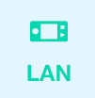
In mBlock, there are several code blocks that you can use to set up a LAN connection. You will find these code blocks in the 'LAN' category of the block field in mBlock. These code blocks are green.

The table below shows an example of these code blocks to set up a LAN connection.

Code block:
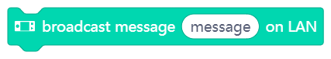
This code block allows you to send a message to all other mBot2 and CyberPi on the same network. You can name the message (like a topic).
Code block:
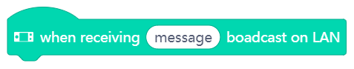
Instead of constantly checking for a received broadcast, there is an event-block. The code attached to this block is only executed once, if a message with the specified topic is received.
In the programming example below, there are two mBot2 and/or CyberPi communicating with each other over a LAN connection using these two code blocks. The first program is the “broadcasting unit”, intended for the first mBot2 or CyberPi. The second program is the receiver-code for the second mBot2 or CyberPi. You can upload both code parts to both CyberPi/mBot2, since the underlying code will make sure that the sending unit does not receive its own message.

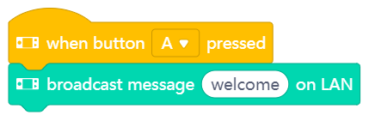
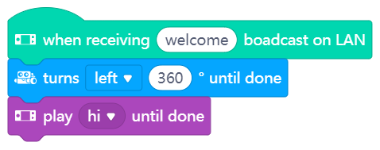

After uploading the programming codes, you must restart the mBot2 and/or CyberPi.
Now when you press A button of the first mBot2 or CyberPi, the second mBot2 or CyberPi will receive the sent message (e.g. welcome). What happens if you press B on the second CyberPi or mBot2? What would you need to change to send different messages back?
Code block:
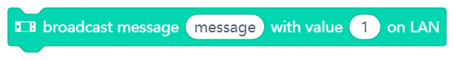
This code block allows you to send a message (with a given topic like before) and a specific value (number or text) to all other mBot2 and CyberPi on the network.
Code block:
For the receiving code, you can use the same event block and specify the topic it should react to exactly like the previous example. To make use of the value (text or number), there is a dedicated reporter block:
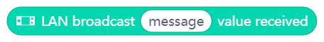
In the programming example below, there are two mBot2 and/or CyberPi communicating with each other over a LAN connection using these two code blocks. The first program is the “broadcasting unit”, intended for the first mBot2 or CyberPi. The second program is the receiver-code for the second mBot2 or CyberPi. You can upload both code parts to both CyberPi/mBot2, since the underlying code will make sure that the sending unit does not receive its own message.

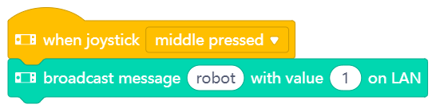
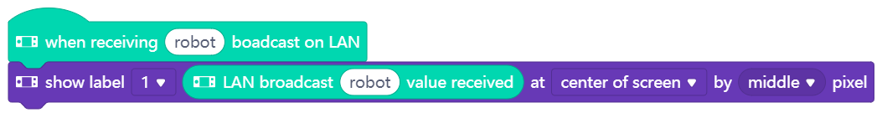

After uploading the programming codes, you must restart the mBot2 and/or CyberPi. If you now press the joystick on the first mBot2 or CyberPi, the second mBot2 or CyberPi will receive the sent message (value 1).

2. Reproducing and testing programming some examples of the LAN communication
In the table above, each code block of the LAN connection is accompanied by a programming example. You are going to recreate these programming examples in mBlock and test them. For one programming example, come up with your own extension.

3. Trying out
(25 min)
Step 3: Trying out
You have already learned a lot about the LAN connection of the mBot2. You are now going to create your own computer program in mBlock using the LAN communication.
In this assignment you are going to program a game by yourself. It is called 'Looking for ... the color blue'. In this game, a group of mBot2 searches for the color blue on the floor. If one of the mBot2 finds the color, it will inform the others via a LAN message and win the game.
Sounds quite complicated! Fortunately, you don't have to program everything yourself. Below you can see a programming example. The same program should be uploaded to all mBot2 so they all follow the same instructions.

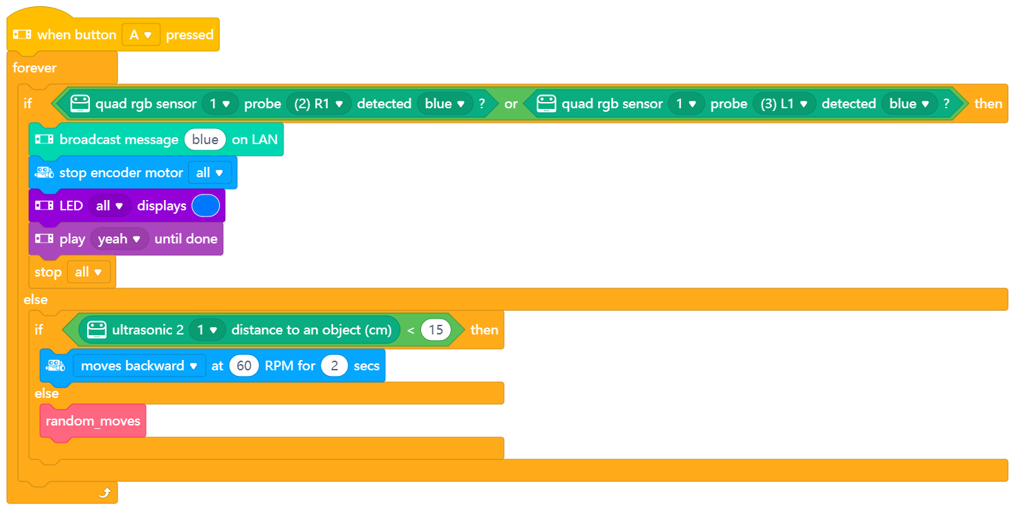
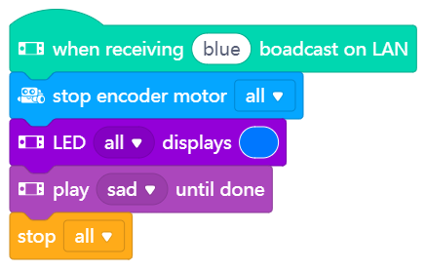
To make the mBot2 drive randomly, you can use the following code block:
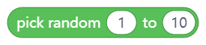
This code block is used to randomly select a value within a certain range. A particular instruction can be assigned to each value of the range. In this way, the mBot2 can choose in a non-linear way from a number of instructions. To make your program easier to understand, you can separate the blocks for this instruction and place them under a custom block, which you can then use in your main program:

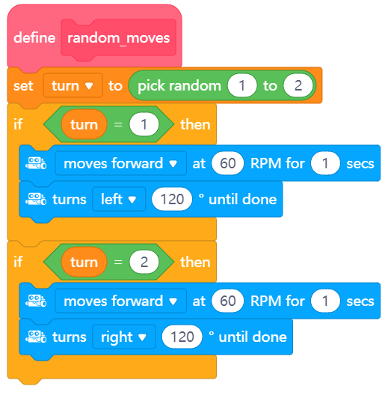
You only have one mBot2? Then you can simulate the communication between two devices by including a sprite in the mBlock stage. The stage is the area on the upper left corner of the mBlock's screen.
You need to add a new extension to the code blocks for the sprite and the mBot2, called “Upload Mode Broadcast”. It allows you to send and receive messages between the sprite and the robot while the robot is in Upload mode, similar to the messages sent via LAN communication.
 | Extension | Add
For the sprite | 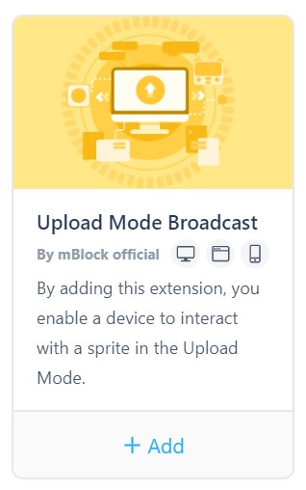 | - Click on 'Sprites'  - Click on 'Extensions'  - Click on 'Sprite extensions'  - Find the extension labelled “Upload Mode Broadcast” and add it
For mBot2 |  | - Click on 'Devices'  - Click on 'Extensions'  - Click on 'Device extensions'  - Find the extension labelled “Upload Mode Broadcast” and add it (might not be on the first page of the Extensions library)
In this programming example, when mBot2 has found the color, it will send a message to the panda sprite in the stage of mBlock, and the panda will say that the mBot2 has found the color.

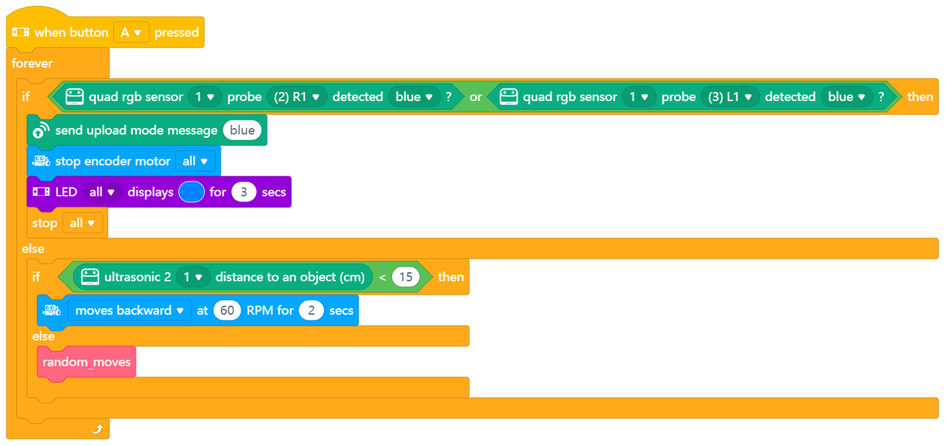
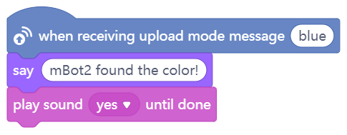

You can copy the above programming examples, but you can also come up with your own extension. It is then useful to use the following step-by-step plan. Do you have any idea of what you want to make? If so, first discuss with your teacher whether this is feasible.

 | Explanation
Step 1: What do you want to do? | - What do you want to program?
Step 2: What do you need? | - What materials do you need to do this?
Step 3: What code blocks do you need? | - How are you going to make the mBot2 drive and communicate?  - What code blocks will you use?  - Make a brief description on how your program works (pseudocode/natural language, flowchart or UML)  - If you need further explanation, you can discuss with your fellow students, the teacher, or do a research on the topic. There is help available for every coding block in mBlock as well.
Step 4: Testing and implementation | - First version ready? Test it! During the testing round, write down points of improvement  - Work on the improvement points until the mBot2 does exactly what you had in mind  - Successful? Film the end result and ask your teacher if you can post it on social media with the hashtag #mbot2LAN

4. Wrap up
(5 min)
Step 4: Wrap up
Did you succeed in programming the game?
In this lesson, you learned what a LAN connection is and where you might encounter it in everyday life. You know how to set up a LAN connection between different devices. You also learned how to create your own LAN network using the mBot2 and the CyberPi. In addition, you know how to add a random selection to a computer program.
It is now time for a brief reflection. Think on your own and discuss with the group:
- What do you think worked out well?
- What could be better?
- Which parts of the lesson did you find easy and which did you find more difficult?
- What would you like more explanation about?
- Who could help you with that?

